**Courier Transfer of Samples from the Children’s Healthcare of Atlanta (CHOA) Center for Advanced Pediatrics (CAP) to the Emory Children’s Center Building (ECC)**

Purpose

The purpose of this document is to outline the process by which clinical trial patient samples will be transferred from the Children’s Healthcare of Atlanta (CHOA) Center for Advanced Pediatrics (CAP), by ExpressLinx, to the Emory Children’s Center Building (ECC).

|  |  |
| --- | --- |
| **Addresses** | **Contact Information** |
| Center for Advanced Pediatrics (CAP)  2174 N Druid Hills Rd NE, 5th floor, Rm 5126  Atlanta, GA 30329 | Mimi Le, PhD  832-335-9750  [uqle@emory.edu](mailto:uqle@emory.edu) |
| Emory Children’s Center Building (ECC)  2015 Uppergate Drive, Lobby  Atlanta, GA 30322 | Mimi Le, PhD  832-335-9750  [uqle@emory.edu](mailto:uqle@emory.edu) |

Pickup Dates and Times

Monday – Friday

11AM and 3PM

Process for Laboratories

1. Secure all samples in need of transport in a biosafety bag.
2. Fill out and place the provided destination label on the biosafety bag.
3. Fill out the sample log.
4. Place the biosafety bag(s) and sample log(s) in the appropriate cold storage location(s).
5. Communicate with your recipient(s) that you have dropped off the sample(s) for courier pickup.

Process for Couriers

1. Upon arrival at the Children’s Healthcare of Atlanta (CHOA) Center for Advanced Pediatrics (CAP), see address above, a courier will be escorted to the Emory Processing Laboratory.
2. After entering the laboratory (Figure 1), the courier will retrieve samples from three locations:
   1. A black basket containing room temperature samples (Figure 2 Left)
   2. An under-counter refrigerator (Figure 2 Right)
   3. An under-counter freezer (Figure 2 Right)

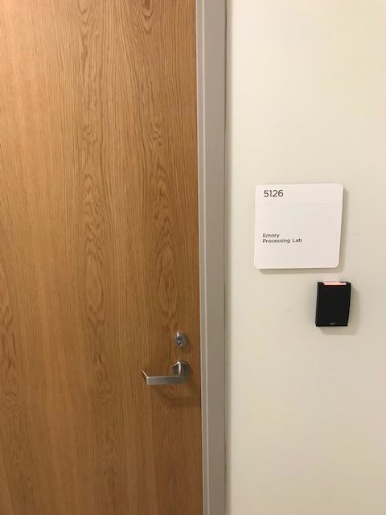

Figure ECC Rm 5126

Figure Left: Room temperature basket Right: Undercounter refrigerator (right) and freezer (left)

All samples should already be placed in biosafety bags with a destination label attached (Appendeix I)

1. Locate the sample log (Appendix II) that details the storage requirements of each sample.
2. A qr code on a white background

   Description automatically generatedVerify that the items on the transfer form match the items that are placed in the pickup location. Any discrepancies can be briefly detailed on the sample transfer form.
3. Scan the QR code at pick up.
4. All samples will then be transferred in the same manner at which they were stored (room temperature, refrigerated or frozen).

QR code 2: for courier

1. Upon arrival at the final destination, the courier should confirm that all samples have the correct destination labels and place all samples with corresponding sample log in the appropriate storage location (Figure 5-7). The code to the fridge/freezer is 322. Scan the QR code above at drop off.

Figure Left: front doors of ECC Building; Right: valet parking circle

Figure Left: lobby area with reception desk on the left; Right: space circled in red marks location of sample drop-off

Figure Fridge/Freezer combo. Room temperature samples should be stored in the basket or on the counter (see Figure 6 Right)

**Appendix I: Destination Labels**

**Appendix II: Sample Transport Log – CAP to ECC**

|  |  |
| --- | --- |
| **Pickup Address** | **Drop-off Address** |
| Center for Advanced Pediatrics (CAP)  2174 N Druid Hills Rd NE, 5th floor, Rm 5126  Atlanta, GA 30329 | Emory Children’s Center Building (ECC)  2015 Uppergate Drive, Lobby  Atlanta, GA 30322 |

Sender: ___________________________________ Email: ___________________________

Recipient: _________________________________ Email: ___________________________

|  |  |  |  |
| --- | --- | --- | --- |
| **Date** | **Time** | **Sample type** | **Sample Condition (circle)** |
|  |  |  | Room Temp / Refrigerator / Freezer |
|  |  |  | Room Temp / Refrigerator / Freezer |
|  |  |  | Room Temp / Refrigerator / Freezer |
|  |  |  | Room Temp / Refrigerator / Freezer |
|  |  |  | Room Temp / Refrigerator / Freezer |
|  |  |  | Room Temp / Refrigerator / Freezer |
|  |  |  | Room Temp / Refrigerator / Freezer |
|  |  |  | Room Temp / Refrigerator / Freezer |
|  |  |  | Room Temp / Refrigerator / Freezer |
|  |  |  | Room Temp / Refrigerator / Freezer |
|  |  |  | Room Temp / Refrigerator / Freezer |
|  |  |  | Room Temp / Refrigerator / Freezer |
|  |  |  | Room Temp / Refrigerator / Freezer |
|  |  |  | Room Temp / Refrigerator / Freezer |
|  |  |  | Room Temp / Refrigerator / Freezer |